|  |
| --- |
|  |
| 新概念 3 册 |
| Lesson60 |

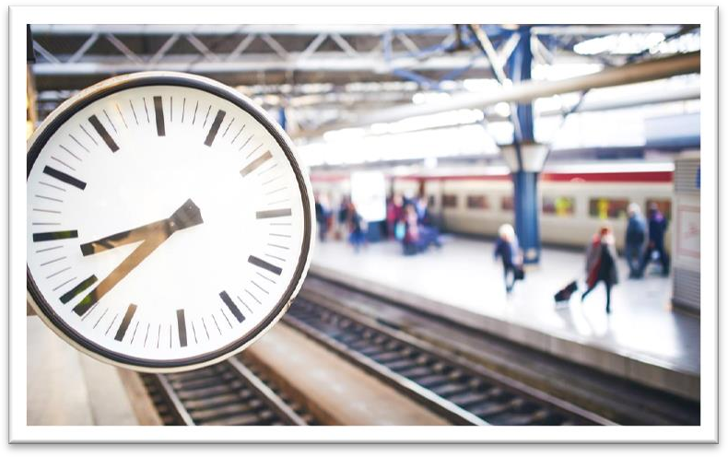Lesson 60 Too early and too late

**punctuality [pʌŋktʃʊ'ælətɪ]**

**n. 守时，准时**

Punctuality is the soul of business. Procrastination is the thief of time. punctual punctually

We have learnt to expect that trains will be punctual.

Sure enough, Rastus arrived punctually at seven o'clock that evening. “punct” = point

punctual punctually punctuality puncture acupuncture punctuate The tyre / tire punctured.

A nail punctured our tyre / tire.

a flat / burst / punctured tyre / tire

The children have not yet learned to punctuate correctly. The transcription of his speech must be punctuated. **rural ['ruərəl]**

adj. 农村的

rural adj. connected with or like the countryside 农村的

rural areas / accents

Only in a sparsely-populated rural community is it possible to disregard it.

pastoral adj. showing country life or the countryside, especially in a romantic way 田园的

a pastoral scene / poem / painting

This idyllic pastoral scene is only part of the picture. urban suburban

metropolitan metropolis

cosmopolitan cosmopolis

intellectual [ɪntə'lektʃuəl]

**n. 知识分子；adj. 智力的**

intellectual intellectual development

intelligent intelligent being

mental mental work

spiritual spiritual civilization

reproach [ri'prəutʃ]

**v. 责备**

reproach v. criticize sb. or oneself, esp. for failing to do sth. 责备

reproach sb. for sth.

The General was reproached by his allies for failing to inform them of his plans. I have nothing to reproach myself for.

But people are often reproached for unpunctuality when their only fault is cutting things fine. criticize sb. for sth.

censure sb. for sth.

reprimand / rebuke sb. for sth. accuse sb. of sth.

scold sb. for sth. blame sb. for sth. blame sth. on sb. condemn A for / as B **fraction ['frækʃn]**

n. 分数；一小部分，些微

a fraction of … ……的一小部分

I bought these shoes at a fraction of its original price.

a fraction of a second / a minute / an inch … 不到一秒钟 / 一分钟 / 一英寸

She hesitated for a fraction of a second before answering. The car stopped within a fraction of an inch of the wall.

If you are catching a train, it is always better to be comfortably early than even a fraction of a minute too late.

a high / large proportion of … a small / tiny proportion of … a high / large percentage of ... a small / tiny percentage of ...

public affairs n. issues and questions about social, economic, political or business activities, etc. that affect ordinary people in general 公众事务

Terrorism is a threat to the civilized world.

造句：礼节 (politeness / courtesy) 是文明社会所有公众事务中一个必备的习惯。

Politeness / Courtesy is a necessary habit in all public affairs in civilized society.

Without it, nothing *could* ever be brought to a conclusion; everything *would* be in a state of chaos.

If we *didn’t* have it nothing *could* ever be brought to a conclusion; everything *would* be in state of chaos.

Without it we *could* not make a living.

If we *didn’t* have it we *could* not make a living. Nothing ever seems to upset him.

bring sth. to a conclusion

In the nineteenth century, a novelist would bring his story to a conclusion by presenting his readers with a series of coincidences—most of them wildly improbable.

draw / come to / reach a conclusion

This trend began during the Second World War, when several governments came to the conclusion that the specific demands that a government wants to make of its scientific establishment cannot generally be foreseen in detail.

这种趋势始于第二次世界大战期间，当时一些国家的政府得出结论：政府要向科研机构提出的具体要求通常是无法详尽预见的。

chaos: disorder; mess; confusion

Only two stray dogs benefited from all this confusion, for they greedily devoured what was left of the cake.

in (a state of) chaos 处于一片混乱（状态）

造句：在老师不在的时候，班里处于一片混乱状态。

In the absence of the teacher, the class was in a state of chaos.

Only in a sparsely-populated rural community *is* it possible to disregard it. sparsely / thinly populated 人口稀少的

densely / thickly populated 人口稠密的

They disregard social conventions without being conscious that they are doing anything extraordinary.

living n. 1. 生计

make / earn a living

2. 生活；生活方式plain / luxurious living the art of living

There can’t be any tolerance of this brutality.

The intellectual, who is working on some abstruse problem, has everything coordinated and organized *for the matter in hand*.

work on sth. / doing 致力于……

John is still working on the new book.

The couple need to work on improving their relationship. abstruse adj. difficult to understand 深奥的；难理解的have sth. done

I’m going to have my hair cut. He had his watch stolen.

By this time, a Lancaster bomber in reasonable condition was rare and worth rescuing. The French authorities had the plane packaged and moved in parts back to France. Now a group of enthusiasts are going to have the plane restored.

the job / task / matter in hand

Could you just concentrate on the job in hand?

As the matter in hand was urgent, we dealt with it at once. I always keep a dictionary close at hand.

My birthday is near at hand.

The signature must be made by hand.

They are always on hand whenever you need them. I can’t remember his phone number off hand.

He is therefore forgiven if (he is) late for a dinner party.

Metals expand when (they are) heated and contract when (they are) cooled.

Francis Preston Blair Jr., although (he was) born in Kentucky, lived and practiced in Missouri. Judges, however wise or eminent (they are), are human and can make mistakes.

While (he was) on a walking tour with his wife, he stopped to talk to a workman.

We’ll resolve the Taiwan issue with peaceful means when (it is) ever possible, with force when (it is) necessary.

cut things fine 时间不留余地，掐钟点

He cut things fine by reaching the classroom only 20 seconds before the bell rang.

It is hard for energetic, quick-minded people *to waste time*, so they are often tempted to finish a job before setting out *to keep an appintment*.

be / feel tempted to do 很想…… I feel tempted to take a day off.

Several times since, she has been tempted to ring him up. Her pride, however, would not let her to do so.

have an appointment 有 约make an appointment 订 约keep an appointment 赴约cancel an appointment 取消约会break an appointment 爽约

If no accidents occur on the way, *like punctured tyres, diversions of traffic, sudden descent of fog*, they will be on time.

a *flat / burst / punctured* tyre / tire

diversion n. (Br.E.) = detour (Am.E.) a different way that traffic is sent when the usual roads are closed （交通）改道

They turned back because of traffic diversions. come down / descend 下雾

A dense fog came down / descended in the afternoon. lift / clear / disperse 雾散

The fog had lifted / cleared / dispersed by late morning. be a trail to sb. 令某人头疼讨厌

She was a trail to her parents when she was younger. as much as ... 和……一样；就等于……

That is as much as to say I am a liar.

I hope you have as much fun as I did. He is as much a bore as his father.

She is as much a beauty as her mother.

… too early / soon 早了……

He arrived ten minutes too early.

… too late 晚了……

He arrived ten minutes too late.

nuisance n. a thing, person or situation that is annoying or causes trouble or problems 令人讨厌的人或事

I don't want to be a nuisance so tell me if you want to be alone.

The only thing to do was *ask them to come half an hour later than the other guests*.

动词不定式做表语时, 若前面出现了实义动词 “do”，则常去掉 “to” All I have to do is dream.

The best thing you can do now is write her an apology. All I wanted was to help him.

The only way that they can preserve their history is to recount it as sagas—legends handed down from one generation of story-tellers to another.

动词不定式做“except / but”的宾语时, 若前面出现了实义动词 “do”, 则常去掉“to” They did nothing but / except complain.

I’ve done everything you wanted but / except make the beds. We have no choice but / except to wait here.

If you are catching a train, it is always better *to be comfortably early than even a fraction of a minute too late*.

catch a train / bus / plane

a fraction of a second / a minute / an inch … 不到一秒钟 / 一分钟 / 一英寸

She hesitated for a fraction of a second before answering. The car stopped within a fraction of an inch of the wall.

Although being early may mean wasting a little time, this will be less *than if you miss the train and have to wait an hour or more for the next one*; and you avoid the frustration *of arriving at the very moment when the train is drawing out of the station and being unable to get on it*.

Although being early may mean wasting a little time, this will be less than (it will be) if you miss the train and have to wait an hour or more for the next one; …

He's never more annoying than when he's trying to help.

He's never more annoying than (he is) when he's trying to help.

Sometimes patients are more depressed six months later than when they first hear the bad news. Sometimes patients are more depressed six months later than (they are) when they first hear the bad news.

pull / draw out of the station pull / draw in / into the station

The train slowly drew in / drew into the station.

And even a harder situation is to be on the platform in good time for a train and still to see it go off without you.

in good time (for sth.) (UK): 早早就……

There wasn’t much traffic so we got there in good time. He arrived in good time for dinner.

befall (befell befallen)=overtake / happen to 不幸的事降临到…… A great misfortune befell him.

We know instinctively, just as beekeepers with their bees, that misfortune might overtake us if the important events of our lives were not related to it.

She entered the station 20 minutes *before the train was due*, since her parents had impressed upon her *that it would be unforgivable to miss it and cause the friends with whom she was going to stay to make two journeys to meet her*.

due: adj. 1. 到期的, 到时间的

When is your baby due? The train is due (in) at 8:00.

She wants the man to be at the station when she arrives.

She isn’t sure which train she’ll be on.

The train will be an hour late.

She’ll leave home at 6:30.

M: It says here the next train is due in at 6:30.

W: I know, but I don’t know whether I can make that one. I’d rather call you from the station than have you waiting around for an hour.

Q: What does the woman imply?

Answer: (B) She isn’t sure which train she’ll be on. due: adj. 2. 适当的

after due consideration

undue / unduly 过度的/过度地

They are either unduly optimistic or unduly pessimistic.

While the quality of legal journalism varies greatly, there is an undue reliance amongst many journalists on interpretations supplied to them by lawyers.

impress sth. on / upon sb.

让某人铭记某事

Father impressed on me *the importance of hard work*.

I had always impressed upon the children *that if they worked hard they would succeed in life*. cause sb. to do 使得某人做某事

make a journey 到某地去

She felt *in her handbag* for the piece of paper on which her father had written down all the details of the journey and gave it to the porter.

feel for … 摸着找……

She felt in her bag for a pencil.

I felt for the switch on the wall and turned it on.

He agreed that a train did come into the station at the time on the paper and that it did stop, but only to take on mail, not passengers.

take on ... 上（货/乘客等）

The bus stopped to take on more passengers. The ship took on more fuel here.

The girl asked to see a timetable, *feeling sure that her father could not have made such a mistake*. timetable / schedule

train / railway / railroad ~ college / school ~

exam / examination ~

The porter went to fetch one and arrived back with the station master, who produced it with a

flourish and pointed out a microscopic 'o' beside the time of the arrival of the train at his station; this little 'o' indicated *that the train only stopped for mail*.

do sth. with a flourish

为了引起注意而用较大的动作自信地/潇洒地做某事

The waiter handed me the menu with a flourish.

The girl, tears streaming down her face, begged to be allowed to slip into the guard's van. break / violate rules

ignore / disregard rules

make / formulate / establish / lay down rules obey / comply with / abide by / observe rules leave sb. / sth. ↔ behind

留下（不带走）

Don’t leave me behind!